College of Liberal Arts 234 Anderson Hall
Department of Political Science PO Box 117325
Gainesville, FL 32611-0000
352-000-0000

Application for Associate Editor Position

Our mission:
The University of Florida International review strives to create a venue for exceptional undergraduate writing in IR; while equally offering an inclusive space that provides students a glimpse into what the world has to offer. This year, it is our goal to offer a compilation of ideas that challenges our readers to think beyond the worldview they inhabit, and to ultimately become global citizens.

Requirements:
· Must be at least a second year University of Florida Student
· Must have taken at least one upper division IR course
· Must have demonstrated the ability to write well

Benefits
Working as an Associate Editor for the University of Florida International Review is a great opportunity for both those interested in law school and graduate studies in the social sciences. Major benefits of joining include exposure to the best Political Science undergraduate research at the University of Florida, improvement of editing skills, interacting with knowledgeable undergraduate submitters, and learning more about the discipline.

How to Apply
In order to apply, submit the following 3 documents to the Editor-in-Chief at this email: ufirjournal@gmail.com by
- Curriculum Vitae:
- Your name
- Major, Minor, Proposed Certificate Programs, and GPA
- Your Field of Interest (Comparative Politics or International Relations) and Specific Topics of Interest (Democratic Peace Theory, International Security, etc.).
- Particular Regional Specializations (Europe, Asia, Latin America, etc.)
- Relevant Coursework and Relevant Research Experience. You can list them.
- Answer the Following Questions in a Word Document
- Why do you want to join the University of Florida International Review? (300 words)
- How will the International Review benefit from having you as part of the Editorial Board? (200 words)
- Resume

Our warmest regards,
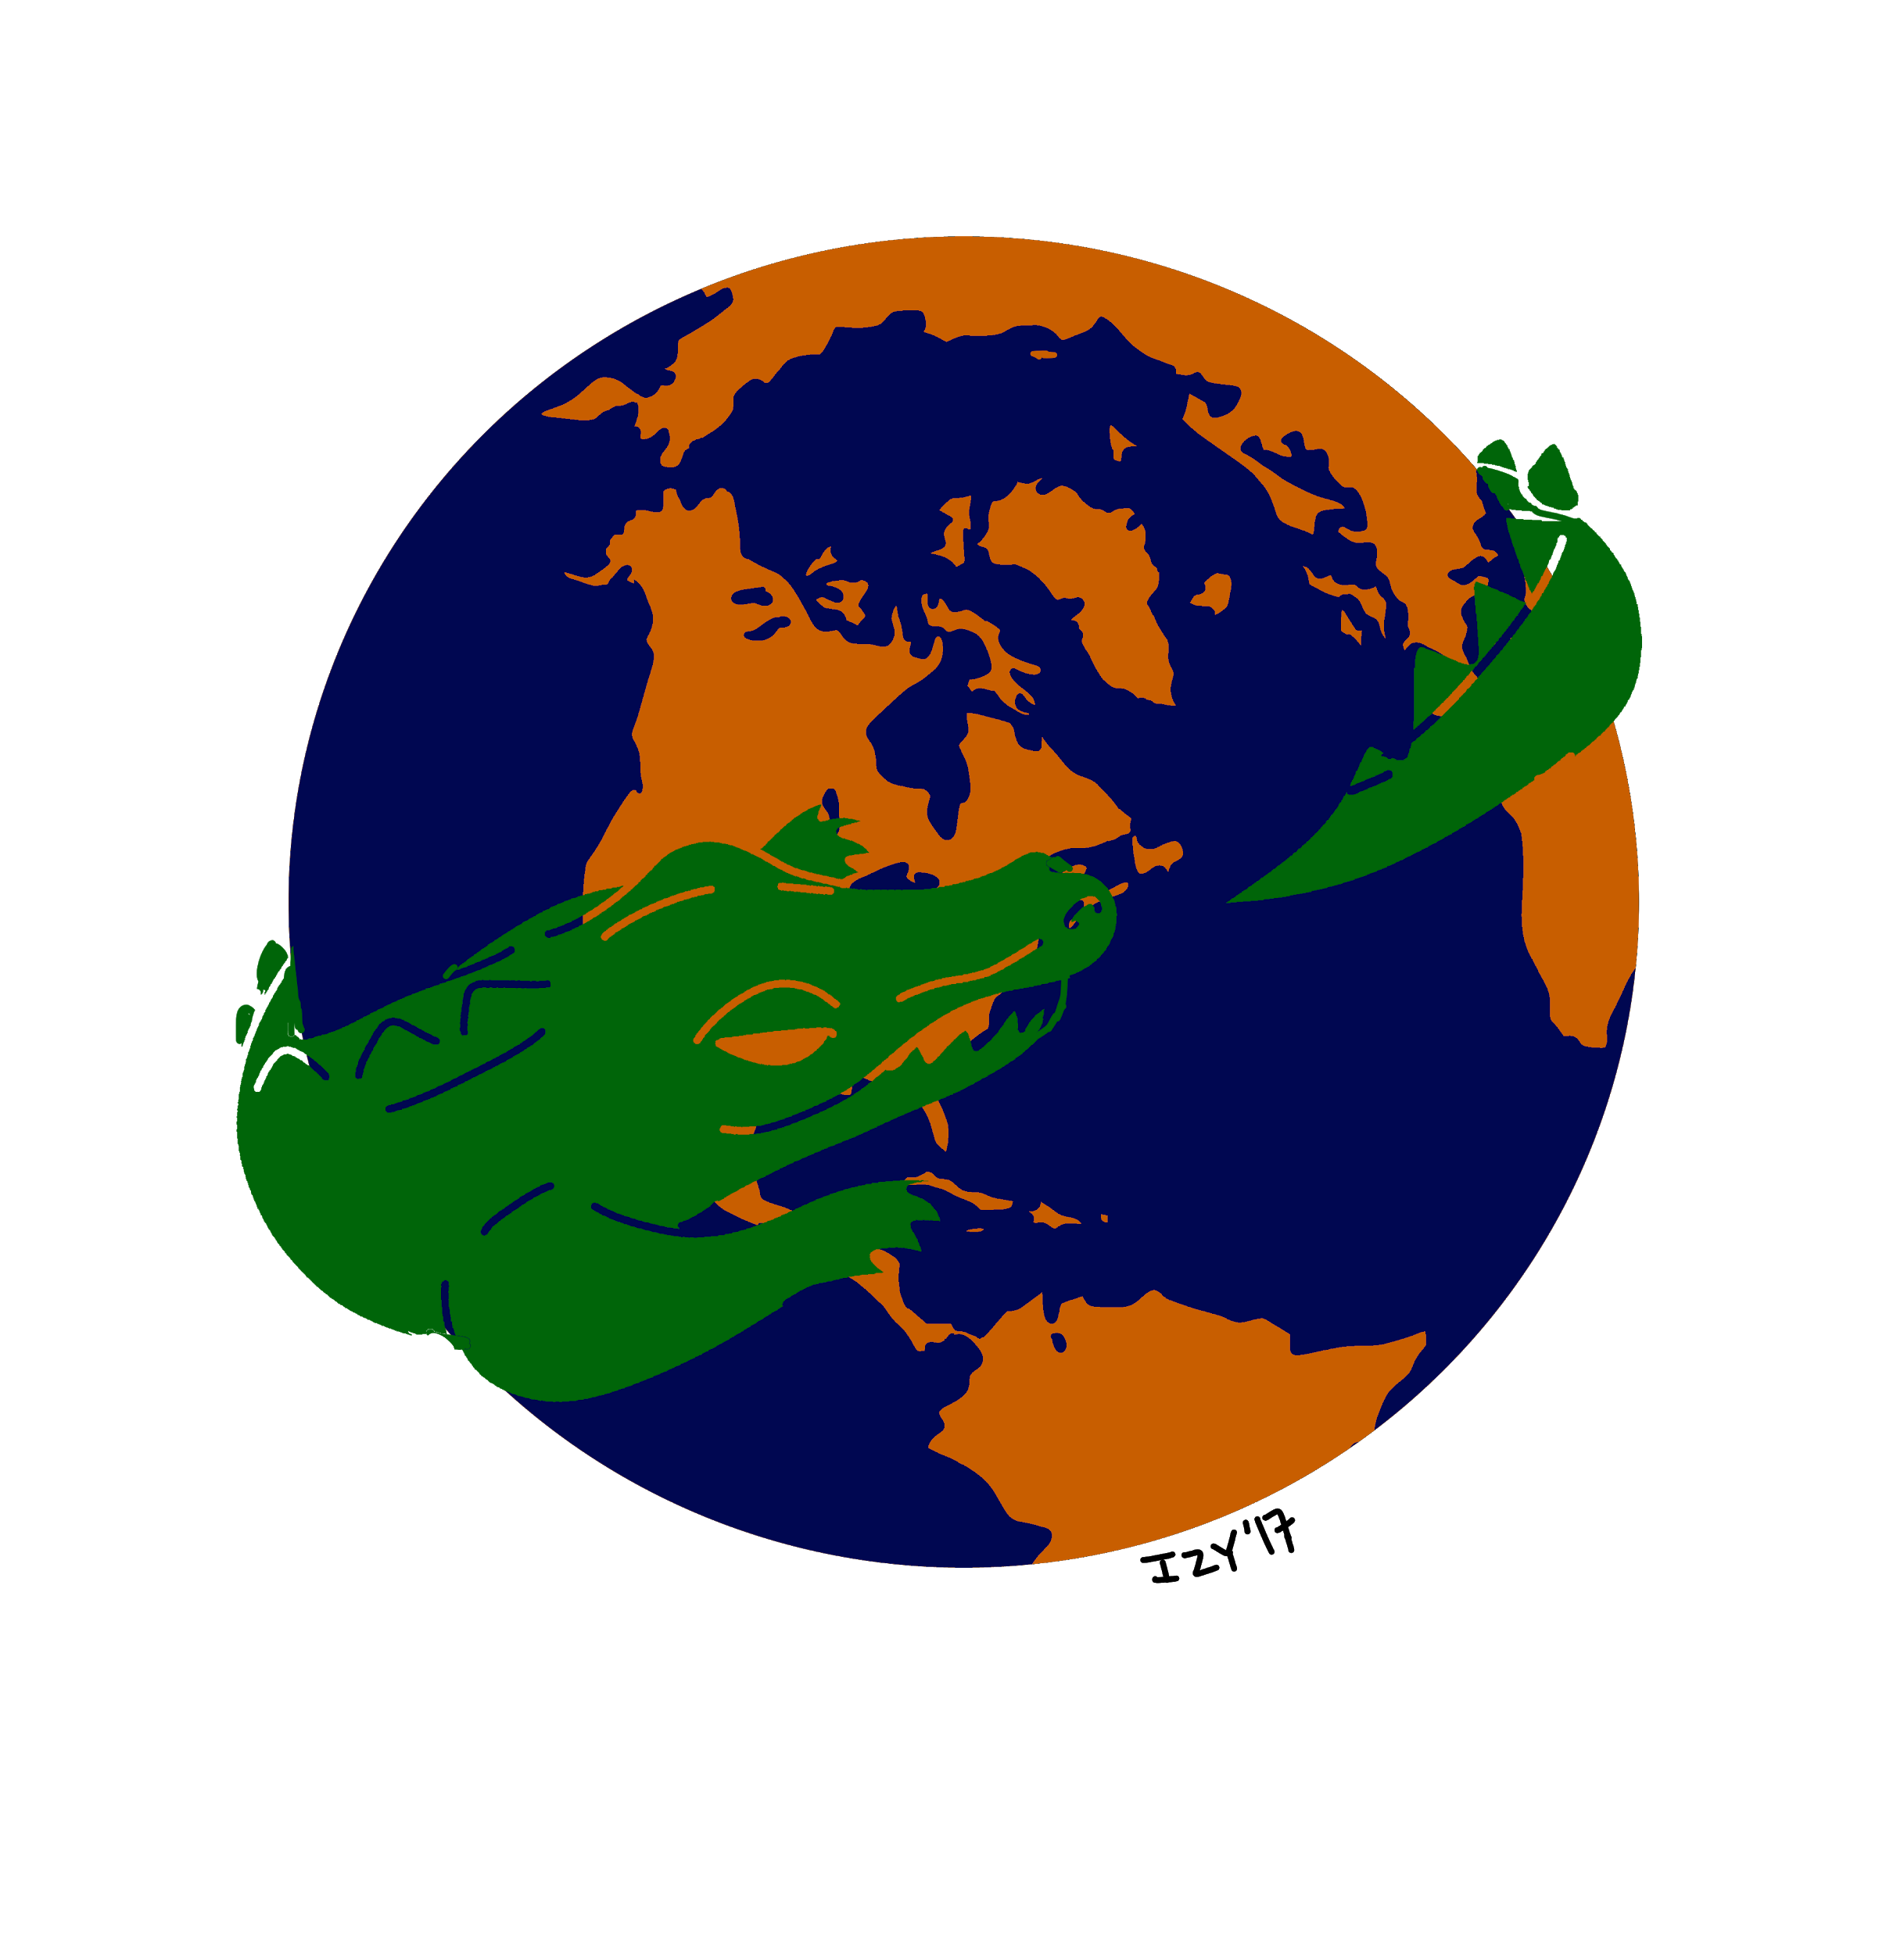 |  | Gabriel Castro  Editor-In-Chief  UF International Review
  727-422-3542 | Gabriel.castro@ufl.edu
  Check out our website here.

